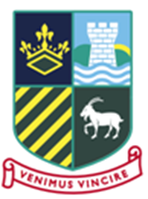

**Sunnydown School**

**CAREERS POLICY**

**Agreed: Autumn 2025**

**Review: Autumn 2026**

**Statutory**

**Annual**

***Our mission***

*To create a successful and unique journey for every young man so that he is:*

Nurtured to be **Resilient**;

Supported to develop **Independence**;

**Cooperative** and his interpersonal skills are enhanced through **Encouragement**;

**Enabled** to be confident and tolerant.

**Empowered** to be responsible.

We intend to raise pupil’s aspirations and enable them to make informed decisions about their future studies and career options. We strive to provide a comprehensive and progressive careers programme that enables pupils to successfully transition to the exciting next stage of their journey.

**Our approach**

We are working towards achieving the 8 Gatsby Benchmarks of good career guidance identified in a report published by Lord Sainsbury’s Gatsby Charitable Foundation in 2014 and use the [Compass + Careers Benchmark Tool](https://compass.careersandenterprise.co.uk/info) to evaluate our provision on a termly basis. We continue to develop our practice using the [SEND Gatsby Benchmark Toolkit](http://www.talentinocareers.co.uk/send-gatsby-benchmark-toolkit.pdf) and are a member of a SEND Careers cluster group with several other special schools in the area Chaired by Enterprise Advisor Lisa Hobbs (Coast to Capital).

**The Gatsby benchmarks**

1. A stable careers programme.  
2. Learning from career and labour market information.

3. Addressing the needs of each pupil.  
4. Linking curriculum learning to careers.  
5. Encounters with employers and employees.  
6. Experiences of workplaces.  
7. Encounters with further and higher education.  
8. Personal guidance.

**Responsibilities:**

* Sunnydown Careers lead **Ben Wright**
* Careers Link Governor **TBC**
* Careers SLT link **TBC** Headteacher
* Careers assistants **Jo Clarke** - TA

**Lee Thompson** - TA

**Gabe Odia** - Teacher

**Emma Thompson** - TA

**Hannah Pletts** - HLTA

**Hayley Peterson** - TA

**Sunnydown Careers programme**

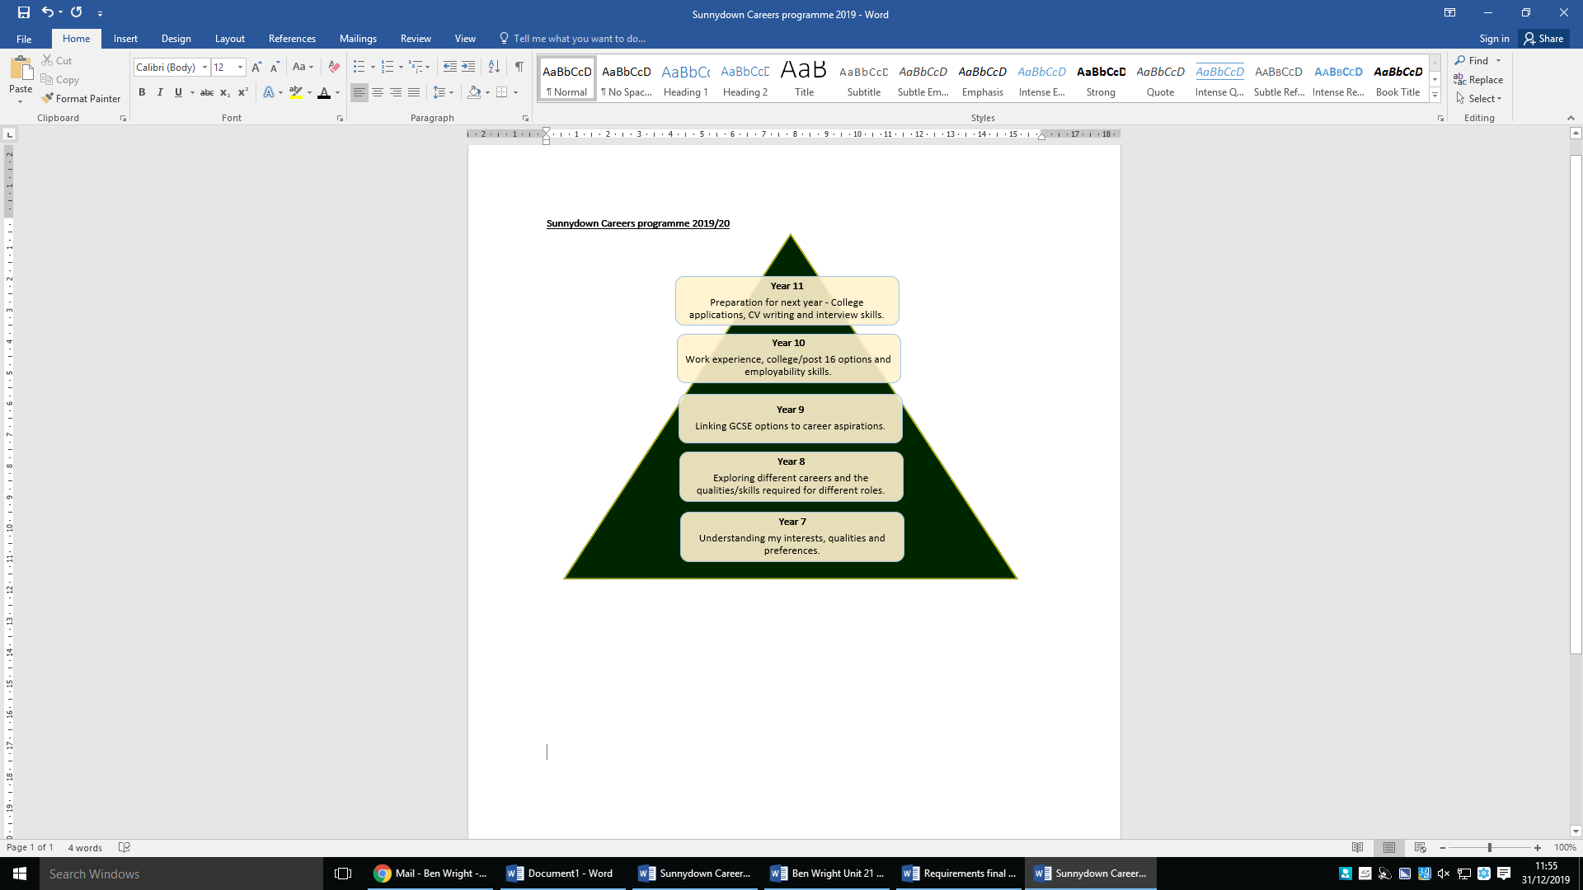

**Our delivery model**

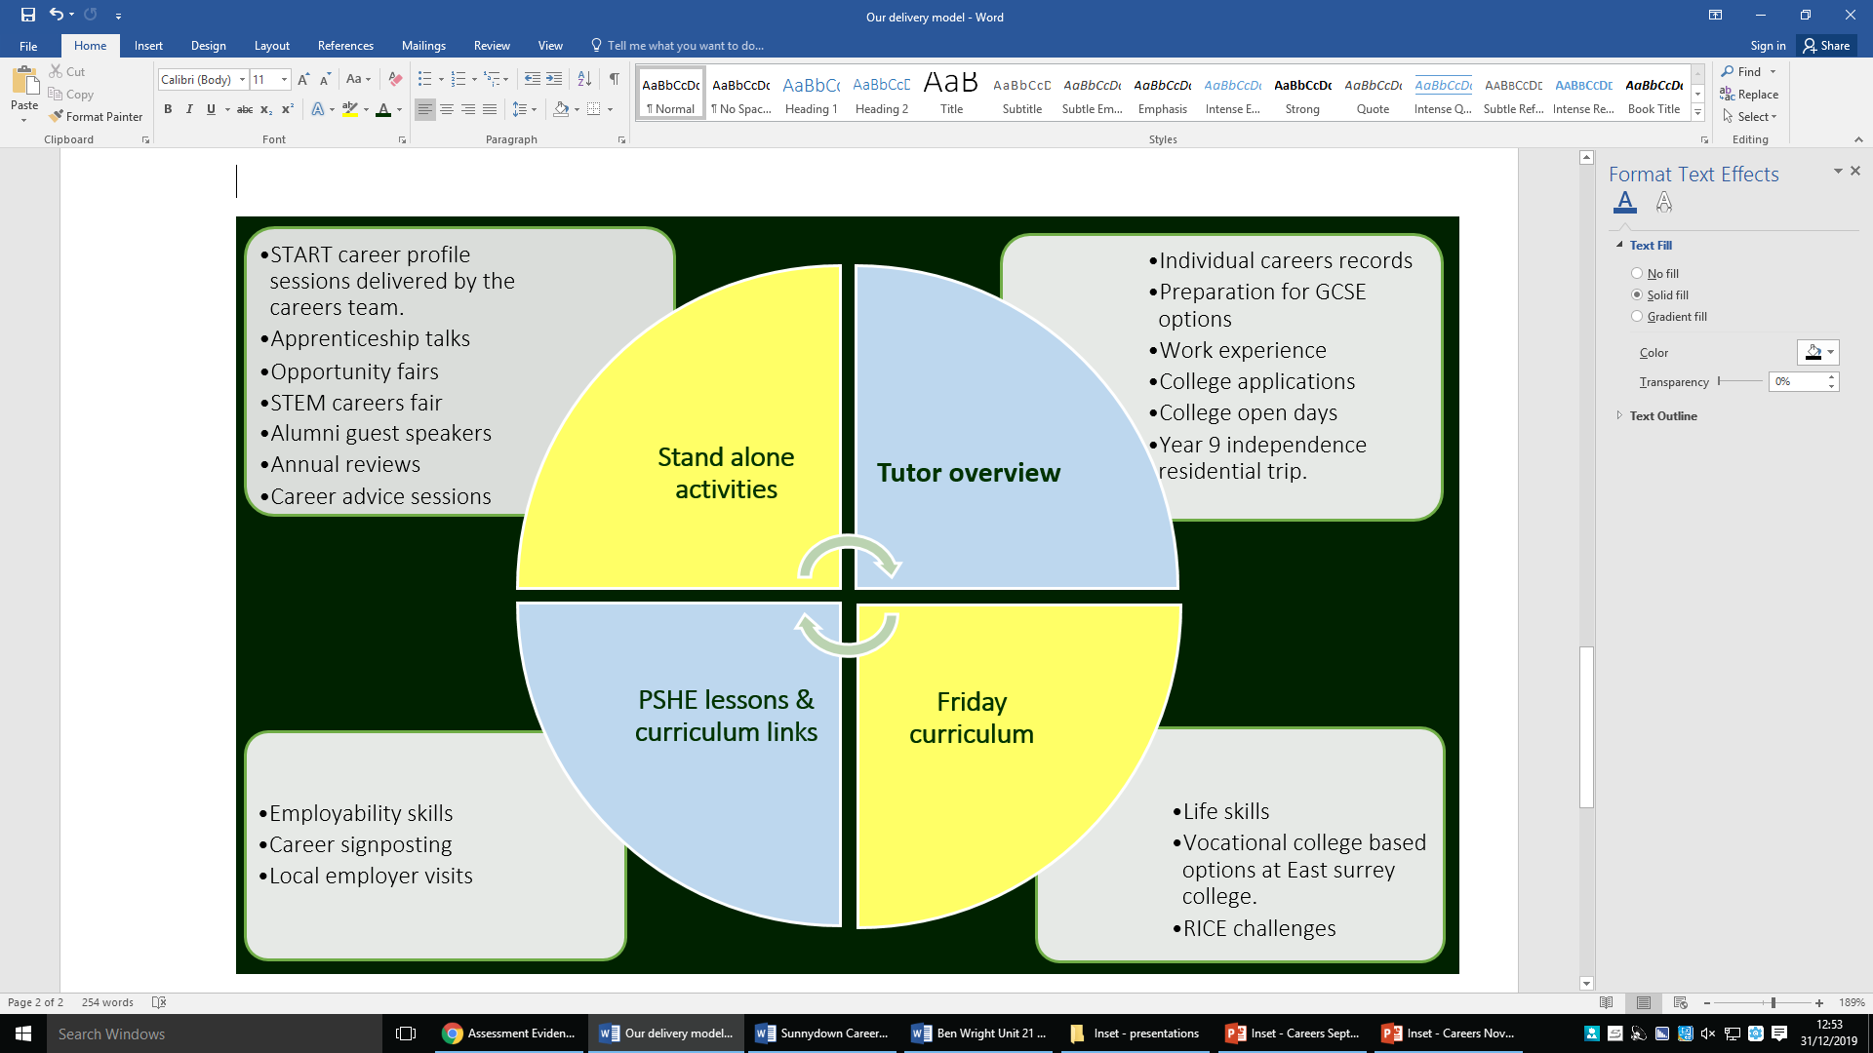

**Careers profiles**

All Sunnydown pupils will have regular access to a **Naturally Talented Me** account, which is a comprehensive web based resource designed to connect pupils with their future career potential. NTM’s approach focuses on the attributes that are at the heart of an individual – their natural talents. Talents that match the needs of a modern-day forward-thinking employer. Each pupil builds his own unique profile and record of achievement over time. This journey starts in Year 7 as pupils start to identify their interests, work preferences and importantly their qualities although these can change over time.





**Partnerships**

Sunnydown has established effective partnerships to enhance our provision for the young men. Partners include:

* Enterprise Advisor - **Tracey Haigh** - Surrey Enterprise Coordinator
* ALPS Network Manager - **Sue Taylor** - Association of learning Providers in Surrey
* Whitecaps - **William Laven** (Alumni) Apprenticeships advisor
* CDI (careers development institute)
* SEND Careers cluster group including Coast to capital, Limpsfield Grange, Woodfield School, The Orpheus Centre, Young Epilepsy, Job centre plus and NESCOT.
* East Surrey College
* Local employers

**Local business links**

Sunnydown hosts events for local businesses and our career partners to enhance links with local employers and to look at ways that we can collectively enhance our provision.

**Equality and diversity**

Equality and Diversity Careers education is provided to all Sunnydown students. All individuals are encouraged to follow career paths that suit their interests, skills and strengths.

**Staff development**

Senior leaders and the careers lead are responsible for delivering key information and updates to staff regarding our statutory requirements and Careers development updates.

Senior leaders and the Careers lead are responsible for identifying CPD (continued professional development) opportunities for Sunnydown staff.

The Careers lead and Careers assistants will attend local authority training and updates and disseminate relevant information to staff. To contact the Careeers Lead or one of the assistants, please contact the school office: [office@sunnydown.surrey.sch.uk](mailto:office@sunnydown.surrey.sch.uk).

The school will source an external Careers Advisor (Level 7) with a view to a Sunnydown member of staff achieving the qualification in the future.

**Review process**

This Careers policy is reviewed annually by the Careers lead in consultation with the headteacher, SLT and Careers link governor. Enhancements are made where necessary and the policy is then submitted to the full governing body for approval.